Bud Rot (Botrytis cinerea) Life cycle diagram

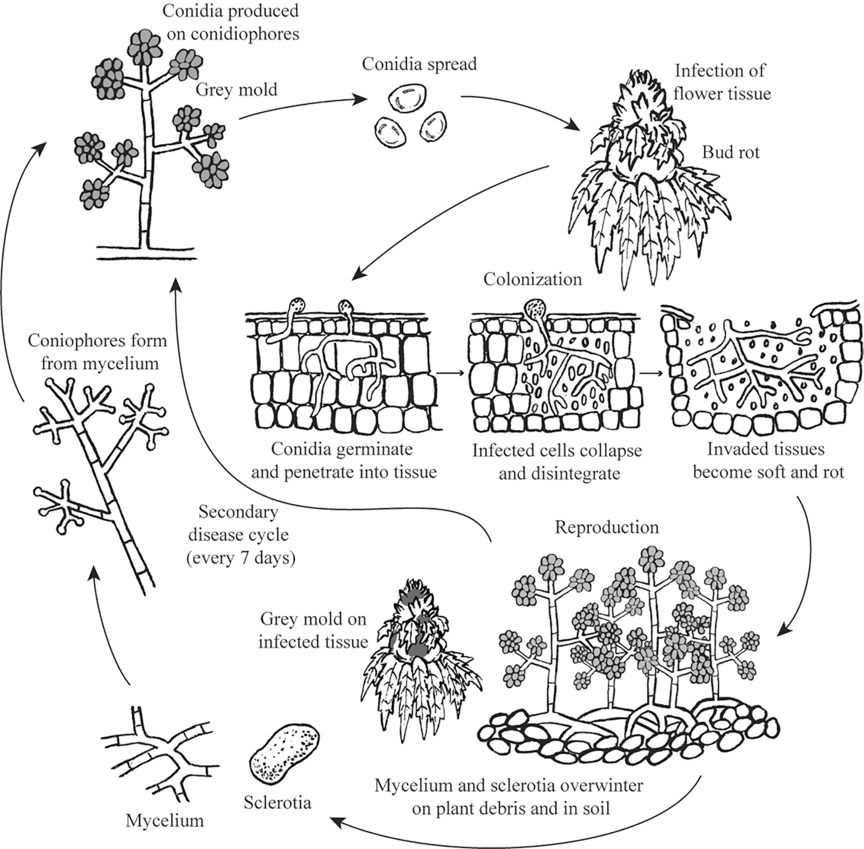Mohannad Mahmoud et al 2023

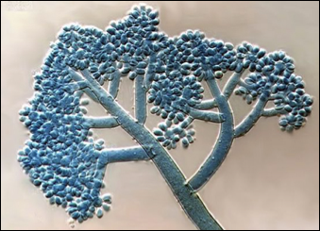
Figure 13.4. Botrytis cinerea asexual reproduction showing the conidiophores that bear all of the conidiospores (conidia 40x).

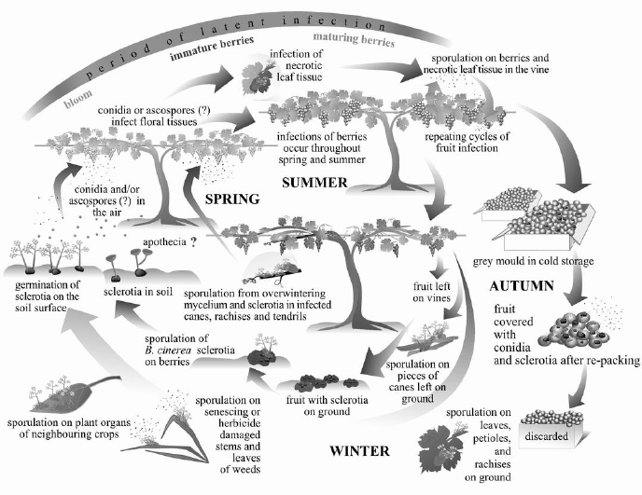

The life cycle of Botrytis cinerea, the fungus that causes gray mold, includes the following stages:
- Spore production
- When conditions are humid and cool, spores are produced on moldy fruit, plant debris, or sclerotia. These spores are spread by wind and water.

- Infection
- Spores germinate when they land on a host plant's leaves or stem and have access to moisture and nutrients. The spore secretes enzymes to break down the plant's waxy outer layer, called the cuticle, and then forms an infection peg that enters the plant tissue.

- Sclerotia
- The fungus survives as small black resting structures called sclerotia in infected plant debris or soil. Sclerotia can also overwinter.

- Conidia
- In the spring, sclerotia germinate and produce conidia, which are asexual spores. Conidia are spread by wind and rain.

- Infection
- When conditions are right, conidia infect flowers, fruit, or leaf tissues. Infected tissues soften and rot due to the fungus releasing necrotrophic enzymes, killing surrounding plant tissue, then the fungus produces more conidia.

- Dispersal
- Conidia are spread by wind and splashing water.

- Repeat
- The cycle repeats, with infected tissues producing more conidia that spread and infect other plants.

Structures:
- Scerotium
- Mycelium
- Conidiophore
- Ascospore
- Conidia
- Aporthecia
- Cannabis flower infected with mycelium
- Penetration of plant tissue with appresoria
- Infection cushion

Botrytis cinerea living endophytically is likely fulfilling this role as a latent saprobe; colonizing healthy tissue to gain first dibs in exploiting it as a food resource once it becomes weakened or begins to senesce. Botrytis cinerea is often seedborne, usually passed on the outside of the seed coat. Though internal seed infestations have been demonstrated in other plant species, and are likely to occur among Cannabis seeds, internal infections are usually a minor source of seed borne Botrytis infections among crops (du Toit et al. 2004).
Botrytis is also able to kill germinating seeds and very young seedlings. Disease at this stage may partly be a function of inoculum density or environmental stressors. Surface sterilization kills the vast majority of seedborne Botrytis inocula, protecting young seedlings during the short window of susceptibility to Botrytis induced damping-off (Sowley et al, 2010). Even if some internally infested seed results in cryptic, systemic infection, these individuals will likely not have any differences in the final amount of disease compared with plants that become infected after germination (Shaw et al. 2016).
This fungus can reproduce via sexual and asexual methods. Asexual reproduction consists of the mycelium producing large amounts of clonal spores, called conidia, on specialized hyphal structures, called conidiophores (Fig. 4). These conidia (conidiospores) will be genetically identical to the mycelium that produced them. Botrytis can form both macro- and microcondia. Conidiophore formation is less resource intensive than the formation of sexual fruiting bodies, and does not require the meeting of different mating types. This makes conidia production a very efficient way for the fungus to replicate itself.
When a compatible mating type is nearby, both mycelia will release signals and the two will fuse, anastomize and exchange nuclei. The teleomorph (sexual state) of Botrytis cinerea has a different binomial name, Botryotinia fuckeliana. Because the anamorph was named first and is ubiquitous, whereas the sexual state is rare, Botrytis cinerea takes precedence.
A member of the Ascomycota, B. cinerea forms a specialized ascocarp, called an apothecium, which has an exposed hymenium (spore producing tissue) on its upper surface. When the ascospores are mature, the ascus will burst, releasing the spores into the wind. Formation of the Botryotinia fuckeliana ascocarp (sexual fruiting body) occurs directly from sclerotia (Fig 5) formed to survive stressful environmental conditions and is rarely encountered by Cannabis farmers.

